Department of Veterans Affairs

OI&T Innovations Program

Radiology Protocol Tool and Reporter (RAPTOR)

Project Management Plan

#: VA118-13-C-0069

Submitted By:

SAN Business Consultants, LLP,

11414 Ramsburg Court

North Potomac, MD 20878

[www.sanbusinessconsultants.com](http://www.sanbusinessconsultants.com)

240 350 5127

Original Submission Date:

October 7, 2013

Version 1.5

June 14, 2014

TableS of Content & Figures

Project Definition 3

1.1 Background 3

1.2 Project Objectives 5

1.3 WBS 7

2 Project Management Approach 15

2.1 Stakeholders and Resources 15

3 Methodology and Tools 17

3.1 Bimonthly Progress Reports 17

3.2 Project Change Control Process 17

3.3 Quality Management Approach 18

3.4 Risk Management Approach 19

3.5 Performance Measures 19

Figure 1 Current Workflow from Order to Schedule 5

Figure 2 Current Protocol Workflow from Schedule to Report 5

Figure 3 RAPTOR replaces paper process 8

Figure 4 Approach of project from Designing and Prototyping in Drupal, D. Nordin, 2012 16

Figure 5 Snapshot of Sandbox Tickets entered by development team 19

**Change Record**

|  |  |  |
| --- | --- | --- |
| **Version** | **Date** | **Revision Description** |
| 1.0 | Oct. 7 2013 | Initial Submission |
| 1.1 | Oct. 9, 2013 | Updates based on feedback |
| 1.2 | Dec. 14 2013 | Updates based on Dec. release |
| 1.3 | Feb. 7 2014 | Updated Submission |
| 1.4 | Mar. 18 2014 | Updates based on March 2014 release demo |
| 1.5 | June 14 2014 | Updates based on June 2014 release demo |

# Project Definition

This project will build RAPTOR, the Radiology Protocol Tool and Reporter. RAPTOR is an electronic protocol workflow application that will utilize open-source open-standards web-based development platform and tools. This project will deliver a functional application that interoperates with VistA.

## Background

Currently, VA Radiologists review all clinician orders for advanced diagnostic imaging (Computerized Tomography, Magnetic Resonance Imaging, and Nuclear Medicine tests) and assign specific protocol instructions directing how each examination must be performed so that the clinical questions are answered. This is standard practice and typically paper based.

VA Radiologists frequently do not receive sufficient information on exam requisitions to optimize the quality and safety of their protocol decisions. Efforts to augment the clinical detail provided by the ordering provider can be cumbersome and negatively impact Radiologist productivity and department efficiency.

Paper processes have inherent shortcomings. Lost and duplicated exam requests negatively impact efficiency. Information necessary for optimized protocol selection can be missing from paper processes and cumbersome to obtain if data is stored in disparate health information repositories, negatively impacting quality of care. Recordable electronic transactions assure documentation of responsibility and provision of secure provider communication protects patient privacy. Electronic emulators of paper processes are at risk of providing non-optimized functionality and falling short of efficiency and quality targets if sufficient systems interoperability is not achieved. Health system requirements e.g. consent for contrast agents, application of conscious sedation protocols and documentation of order changes within an optimized environment for advanced imaging procoling decisions. Utilization of open standard, open source architecture and tools to support reliable functionality, maintainable extensions and minimize ownership costs and development time predict accessibility, versatility and scalability.

The figures below illustrate the typical current manual radiology process from order request to procedure protocol to schedule patient though imaged and reported.

Figure 1 Current Workflow from Order to Schedule



Figure 2 Current Protocol Workflow from Schedule to Report



## Project Objectives

The Radiology Protocol Tool and Reporter (known as RAPTOR) will:

* Leverage VHA information systems to maximize Radiologist advanced imaging protocoling effectiveness while preserving productivity.
* Protocol decisions will occur within a tailored electronic environment displaying and coordinating functionality of all information and resources needed to make rapid, informed protocol decisions and actions.
* Provide to Radiologists
  + Exam order
  + Access to all pertinent textual data (allergies, medications, provider notes, imaging reports, ionizing radiation exposure history, etc.)
  + Initially presented data will be filtered for relevance
  + Access to previous imaging exams (the actual image data)
  + Protocol action space (to record protocol decision and need for patient informed content or conscious sedation)
  + Messaging portal to streamline (and catalog) non-urgent communication with referring providers, when necessary

Process attributes were defined and opportunities to leverage information systems interoperability and process functionality improvements were identified to guide development of a comprehensive electronic solution. Attribute comparison between existing paper and identified existing local VA electronic advanced medical imaging solutions with optimized prototype design:

Table 1 Comparison between paper and RAPTOR

| **Attribute** | **Existing Paper Processes** | **RAPTOR Solution** |
| --- | --- | --- |
| Environment | Paper | Web – based |
| Level of interoperability | Paper or scanned paper | Computational electronic data |
| User access | Poor security controls | Access through authenticated secure services |
| User roles | Radiologists, Technologists, Schedulers | Radiologists, Technologists, Schedulers & System Administrators |
| Interface – textual input | Manual | CPRS orders |
| Interface – images & reports & clinical data | Not integrated, cumbersome | Integrated information dashboard, optimized data access |
| Signature | Technologist & radiologist initials on paper form | Digital |
| Record management | Can be scanned into EHR, but typically shred | Saved and accessible for management |
| Workflow distribution | Paper stack | Work list |
| Urgency | Listed; not prioritized | Prioritized |
| Communications with requestor | Telephone contact listed, but not integrated | Electronic text comments and secure messaging |
| Communications with technician | Freehand text comments field | Electronic text comments and secure messaging |
| Provider alerts | Not automated | Automated detection of patients at high risk for IV contrast administration (allergies, renal function, informed consent flag), and repeat/duplicated exams. |
| Availability | 24/7 | 24/7 |
| Contrast dosing recording | No | Yes |

Evaluation of existing paper-based and electronic advanced imaging protocol assignment processes in use within the VHA enterprise has identified inefficiencies as well as opportunity for innovative solutions to improve productivity, quality and patient safety. Lessons learned are applicable to the broader health care marketplace.

Figure 3 RAPTOR replaces paper process

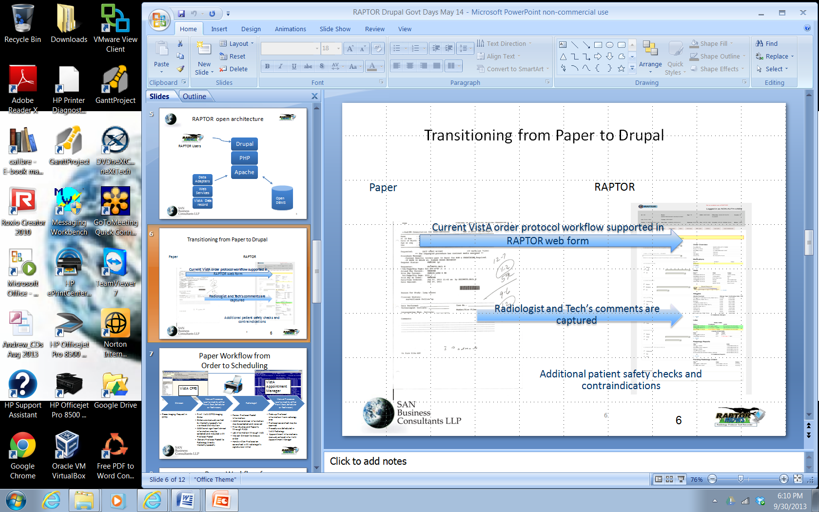

RAPTOR will pilot “optimized” electronic protocol functionality using “open-source, open-standard” methodology where possible and practical. According to the VistA Modernization Strategy, “open-source, open standards”. (VistA Modernization Report, Legacy to Leadership, May 2010 ref. <http://www.scribd.com/doc/32083560/VistA-Modernization-Report-Legacy-to-Leadership-May-4-2010>) technology should be targeted. SAN shall review “open-source, open standards” to determine the best technology platform for the RAPTOR application.

## WBS

Table 2 below shows the project tasks, start and finish date and their resources. The WBS development release schedule can be summarized as a fifteen month development project with five planned quarterly releases. Additional unscheduled releases may occur during the project. All the releases will occur in the sandbox and the last release will also occur on the production servers.

Each release’s functionality will include VA inspection and/or testing procedures to verify application behavior. The last release will be used to complete UAT and will occur in both the sandbox and on the production servers.

Table 2 Project WBS

| # | Task Name | Start | Finish | Resource Names | Status |
| --- | --- | --- | --- | --- | --- |
|  | **RAPTOR** | **Mon 9/23/13** | **Wed 12/23/14** |  | On track |
| **1.0** | **Project Management** | **Mon 9/23/13** | **Tue 12/23/14** | **PM** | On track |
| 1.1 | Create PM Plan | Mon 9/23/13 | Tue 10/8/13 | PM | Completed on time |
| 1.2 | Establish Sandbox access for team | Mon 9/23/13 | Tue 10/8/13 | SAN | Completed on time |
| 1.3 | Identify risks and their mitigations | Mon 9/23/13 | Tue 10/8/13 | SAN | Completed on time |
| 1.4 | Provide Kickoff Meeting Agenda | Thu 10/3/13 | Thu 10/3/13 | PM | Completed on time |
| 1.5 | Kickoff meeting & follow-up | Tue 10/8/13 | Tue 10/8/13 | SAN & VA | Completed on time |
| 1.6 | Update PMP based on Kickoff meeting review | Tue 10/8/13 | Fri 10/18/13 | SAN & VA | Completed on time |
| 1.7 | Provide Kickoff Meeting Minutes | Fri 10/18/13 | Fri 10/25/13 | PM | Completed on time |
| 1.8 | Identify needed resources | Mon 9/23/13 | Tue 12/23/14 | SAN | Completed on time |
| 1.9 | Maintain Project Management Plan | Tue 10/8/13 | Tue 12/23/14 | PM | On track |
| **2.0** | **Bimonthly Progress Reports** | **Mon 9/23/13** | **Tue 12/23/14** | **PM** | **On track** |
| 2.1 | Bimonthly Progress Report #1 | Mon 9/23/13 | Mon 10/7/13 | PM | Completed on time |
| 2.2 | Bimonthly Progress Report #2 | Mon 10/7/13 | Wed 10/23/13 | PM | Completed on time |
| 2.3 | Bimonthly Progress Report #3 | Wed 10/23/13 | Thu 11/7/13 | PM | Completed on time |
| 2.4 | Bimonthly Progress Report #4 | Thu 11/7/13 | Sat 11/23/13 | PM | Completed on time |
| 2.5 | Bimonthly Progress Report #5 | Sat 11/23/13 | Sat 12/7/13 | PM | Completed on time |
| 2.6 | Bimonthly Progress Report #6 | Sat 12/7/13 | Sat 12/21/13 | PM | Completed on time |
| 2.7 | Bimonthly Progress Report #7 | Tue 1/7/14 | Tue 1/7/14 | PM | Completed on time |
| 2.8 | Bimonthly Progress Report #8 | Tue 1/7/14 | Thu 1/23/14 | PM | Completed on time |
| 2.9 | Bimonthly Progress Report #9 | Thu 1/23/14 | Fri 2/7/14 | PM | Completed on time |
| 2.20 | Bimonthly Progress Report #10 | Fri 2/7/14 | Sun 2/23/14 | PM | Completed on time |
| 2.11 | Bimonthly Progress Report #11 | Sun 2/23/14 | Fri 3/7/14 | PM | Completed on time |
| 2.12 | Bimonthly Progress Report #12 | Fri 3/7/14 | Sun 3/23/14 | PM | Completed on time |
| 2.13 | Bimonthly Progress Report #13 | Mon 3/24/14 | Mon 4/7/14 | PM | Completed on time |
| 2.14 | Bimonthly Progress Report #14 | Mon 4/7/14 | Wed 4/23/14 | PM | Completed on time |
| 2.15 | Bimonthly Progress Report #15 | Wed 4/23/14 | Wed 5/7/14 | PM | Completed on time |
| 2.16 | Bimonthly Progress Report #16 | Wed 5/7/14 | Fri 5/23/14 | PM | Completed on time |
| 2.17 | Bimonthly Progress Report #17 | Fri 5/23/14 | Sat 6/7/14 | PM | Completed on time |
| 2.18 | Bimonthly Progress Report #18 | Mon 6/9/14 | Mon 6/23/14 | PM |  |
| 2.19 | Bimonthly Progress Report #19 | Mon 6/23/14 | Mon 7/7/14 | PM |  |
| 2.20 | Bimonthly Progress Report #20 | Mon 7/7/14 | Wed 7/23/14 | PM |  |
| 2.21 | Bimonthly Progress Report #21 | Wed 7/23/14 | Thu 8/7/14 | PM |  |
| 2.22 | Bimonthly Progress Report #22 | Thu 8/7/14 | Sat 8/23/14 | PM |  |
| 2.23 | Bimonthly Progress Report #23 | Sat 8/23/14 | Sun 9/7/14 | PM |  |
| 2.24 | Bimonthly Progress Report #24 | Sun 9/7/14 | Tue 9/23/14 | PM |  |
| 2.25 | Bimonthly Progress Report #25 | Tue 9/23/14 | Tue 10/7/14 | PM |  |
| 2.26 | Bimonthly Progress Report #26 | Tue 10/7/14 | Thu 10/23/14 | PM |  |
| 2.27 | Bimonthly Progress Report #27 | Thu 10/23/14 | Fri 11/7/14 | PM |  |
| 2.28 | Bimonthly Progress Report #28 | Fri 11/7/14 | Sun 11/23/14 | PM |  |
| 2.29 | Bimonthly Progress Report #29 | Sun 11/23/14 | Sun 12/7/14 | PM |  |
| 2.30 | Bimonthly Progress Report #30 | Mon 12/8/14 | Tue 12/23/14 | PM |  |
| **3.0** | **Fully documented Software Coding for each Increment** | **Mon 9/23/13** | **Tue 12/23/14** | **Development team** | On track |
|  | First Increment Style Sheets | 9/23/2013 | Mon 12/23/13 | Development team | Completed on time |
|  | Second Increment Enhanced Style Sheets and HTML | 12/23/2013 | Sun 3/23/14 | Development team | Completed on time |
|  | Third Increment Enhanced Style Sheets, PHP and HTML | 3/23/2014 | Mon 6/23/14 | Development team | On track |
|  | Fourth Increment Enhanced Style Sheets, DB schema, PHP and HTML | 6/23/2014 | Tue 9/23/14 | Development team |  |
|  | Fifth Increment Code Enhanced Style Sheets, DB schema, PHP and HTML | 9/23/2014 | Tue 12/23/14 | Development team |  |
| **4.0** | **Product Build Upon Completion** | **Mon 9/23/13** | **Tue 12/23/14** | **Development team** | On track |
| 4.1 | Identify sandbox development tools | 9/23/2013 | 12/23/2013 | Development team | Completed on time |
| 4.2 | Prepare sandbox development environment | 9/23/2013 | 12/23/2013 | Development team | Completed on time |
| 4.3 | Prepare initial UI mockup for review | 9/23/2013 | 12/15/2013 | Development team | Completed on time |
| 4.4 | Initial UI mockup for review & feedback | 12/15/2013 | 12/23/2013 | Development team | Completed on time |
| 4.5 | Repeat 4.1 to 4.4 for Second Increment | 12/23/2013 | 3/23/2014 | Development team | Completed on time |
| 4.6 | Repeat 4.1 to 4.4 for Third Increment | 3/24/2014 | 6/23/2014 | Development team | Completed on time |
| 4.7 | Repeat 4.1 to 4.4 for Fourth Increment | 6/24/2014 | 9/23/2014 | Development team |  |
| 4.8 | Repeat 4.1 to 4.4 for Fifth Increment | 9/24/2014 | 12/23/2014 | Development team |  |
| **5.0** | **Software Code Generation Documentation** | **Mon 9/23/13** | **Tue 12/23/14** | **Development team** | On track |
| 5.1 | Prepare initial draft for review | 9/23/2013 | 12/13/2013 | Development team | Completed on time |
| 5.2 | Submit UI draft review & obtain feedback | 12/13/2013 | 12/23/2013 | VA | Completed on time |
| 5.3 | Software Code Plans for Increment One | 12/23/2013 | 12/23/2013 | Development team | Completed on time |
| 5.4 | Repeat 5.1 to 5.3 for Second Increment | 12/23/2013 | 3/23/2014 | SAN, VA | Completed on time |
| 5.5 | Repeat 5.1 to 5.3 for Third Increment | 3/23/2014 | 6/23/2014 | SAN, VA | Completed on time |
| 5.6 | Repeat 5.1 to 5.3 for Fourth Increment | 6/23/2014 | 9/23/2014 | SAN, VA |  |
| 5.7 | Repeat 5.1 to 5.3 for Fifth Increment | 9/23/2014 | 12/23/2014 | SAN, VA |  |
| **6.0** | **Product Sandbox Demonstration** | **Mon 9/23/13** | **Tue 12/23/14** | **Development team** | On track |
| 6.1 | Walkthrough of RAPTOR test data after completion of increment one for the VA product owner(s) | 12/23/2013 | 1/7/2014 | Development team | Completed on time |
| 6.2 | User feedback of current sandbox for the VA product owner(s) | 12/23/2013 | 1/7/2014 | VA | Completed on time |
| 6.3 | Demonstration of RAPTOR after completion of increment three for the VA product owner(s) | 3/23/2014 | 3/30/2014 | Development team | Completed on time |
| 6.4 | Demonstration of RAPTOR after completion of increment four for the VA product owner(s) | 6/23/2014 | 6/30/2014 | SAN,VA | Scheduled demonstration for 6/24 |
| 6.5 | Demonstration of feature complete RAPTOR after completion of increment four for the VA product owner(s) | 9/23/2014 | 9/30/2014 | Development team |  |
| **7** | **UAT plan** | **Mon 9/23/13** | **Tue 12/23/14** | **Test** | On track |
| 7.1 | Participate in UAT planning | Mon 9/23/13 | Tue 12/23/14 | Test | On track |
| 7.2 | Prepare UAT data in sandbox | Mon 9/23/13 | Fri 12/13/13 | Test | Completed on time |
| 7.3 | Submit draft review & obtain feedback | Fri 11/13/13 | Mon 12/23/13 | VA | Completed on time |
| 7.4 | UAT Test Review for Increment One | Mon 12/23/13 | Mon 12/23/13 | Test | Completed on time |
| 7.5 | Repeat 7.1 to 7.3 for Second Increment | Mon 12/23/13 | Sun 3/23/14 | Test | Completed on time |
| 7.6 | Repeat 7.1 to 7.3 for Third Increment | Mon 3/24/14 | Mon 6/23/14 | Test | Completed on time |
| 7.7 | Repeat 7.1 to 7.3 for Fourth Increment | Mon 6/23/14 | Tue 9/23/14 | Test |  |
| 7.8 | Repeat 7.1 to 7.3 for Fifth Increment | Tue 9/23/14 | Tue 12/23/14 | Test |  |
| **8** | **UAT Test Cases** | **Mon 9/23/13** | **Mon 12/23/14** | **Test** | **On Track** |
| 8.1 | Create UAT data | Mon 9/23/13 | Fri 12/13/13 | Test | Completed on time |
| 8.2 | Submit draft review & obtain feedback | Wed 12/18/13 | Mon 12/23/13 | Test, VA | Completed on time |
| 8.3 | UAT Test Data complete in support of sandbox testing | Mon 12/23/13 | Mon 12/23/13 | Test | Completed on time |
| 8.4 | Repeat 8.1 to 8.3 for Second Increment | Mon 12/23/13 | Sun 3/23/14 | Test | Completed on time |
| 8.5 | Repeat 8.1 to 8.3 for Third Increment | Mon 3/24/14 | Mon 6/23/14 | Test | Completed on time |
| 8.6 | Repeat 8.1 to 8.3 for Fourth Increment | Mon 6/23/14 | Tue 9/23/14 | Test |  |
| 8.7 | Repeat 8.1 to 8.3 for Fifth Increment | Tue 9/23/14 | Tue 12/23/14 | Test |  |
| **10** | **UAT Testing** | **Mon 9/23/13** | **Tue 12/23/14** | **PM, Test, VA** | **On Track** |
| 10.1 | Oversee the review of test data and documenting the issues found | Mon 9/23/13 | Fri 12/13/13 | Test | Completed on time |
| 10.2 | Submit UAT data & validate | Fri 12/13/13 | Mon 12/23/14 | Test | Completed on time |
| 10.3 | Final UAT for Increment One | Mon 12/23/14 | Mon 12/23/14 | Test | Completed on time |
| 10.4 | Repeat 10.1 to 10.3 for Second Increment | Mon 12/23/13 | Sun 3/23/14 | Test | Completed on time |
| 10.5 | Repeat 10.1 to 10.3 for Third Increment | Mon 3/24/14 | Mon 6/23/14 | Test | On track |
| 10.6 | Repeat 10.1 to 10.3 for Fourth Increment | Mon 6/23/14 | Tue 9/23/14 | Test |  |
| 10.7 | Repeat 10.1 to 10.3 for Fifth Increment | Tue 9/23/14 | Tue 12/23/14 | Test |  |
| 10.8 | Test communications in production | Tue 9/23/14 | Tue 12/23/14 | Test |  |
| 10.9 | Successfully complete UAT in production | Mon 12/1/14 | Tue 12/23/14 | Test, VA |  |
| **11** | **UAT Test Report** | **Tue 9/23/14** | **Tue 12/23/14** | **Test** |  |
| 11.1 | Prepare Close-Out Meeting Minutes | Mon 9/23/14 | Sat 12/13/14 | Test |  |
| 11.2 | Submit Project Summary and Production Integration/Transition Report | Fri 12/13/14 | Tue 12/23/14 | Test |  |
| 11.3 | Gather all testing results to include any issues found | Tue 9/23/14 | Tue 12/23/14 | Test |  |
| **9** | **RAPTOR Equipment** | **Mon 9/23/13** | **Tue 12/23/14** | **HW** |  |
| 9.1 | Purchase Equipment | Mon 9/23/13 | 9/23/2014 | HW | On track |
| 9.2 | Finalize operating system selection and database selection | Tue 10/15/13 | 11/30/2013 | HW | Completed on time |
| 9.3 | Obtain Warranties and Licenses for RAPTOR Equipment | Tue 5/23/14 | 12/23/2014 | HW |  |
| 9.4 | Deliver Equipment | Tue 8/23/14 | 10/23/2014 | HW |  |
| 9.5 | Identify Production RAPTOR Prototype requirements and application validation | Mon 9/23/13 | 9/23/2014 | HW | On track |
| 9.6 | Assist the VA PM to ensure compliance with VA security guidelines and VA Region 1 Sacramento Data Center Application requirements | Mon 9/23/13 | 9/23/2014 | SAN, VA | On track |
| 9.7 | Configure servers in accordance with VA OIT Region 1 Sacramento Data Center server requirements | Tue 9/23/14 | 12/23/2014 | SAN HW |  |
| **12** | **Technical Inputs for Authority to Operate (ATO) Documentation** | **Tue 9/23/14** | **Tue 12/23/14** | **Development team** |  |
| 12.1 | Prepare initial draft for review | Mon 9/23/14 | Tue 9/23/14 | Development team |  |
| 12.2 | Submit draft review & obtain feedback | Tue 9/23/14 | Tue 12/23/14 | Development team |  |
| 12.3 | Final Technical Inputs for Authority to Operate (ATO) Documentation | Tue 9/23/14 | Tue 12/23/14 | Development team |  |
| **13** | **Pilot Assessment Report and Presentation** | **Tue 9/23/14** | **Tue 12/23/14** | **Development team** |  |
| 13.1 | Prepare Close-Out Meeting Minutes | Mon 9/23/14 | Sun 11/23/14 | Development team |  |
| 13.2 | Submit Project Summary and Production Integration/Transition Report | Tue 9/23/14 | Tue 12/23/14 | Development team |  |
| **14** | **OSEHRA transition** | **Mon 9/23/14** | **Mon 12/23/14** | **Development team** |  |
| 14.1 | Prepare OSEHRA Checklist and Project Abstract (plus source code and developer documentation if not previously submitted) | Mon 9/23/14 | Tue 9/23/14 | Development team |  |
| 14.2 | Submission of Final Deliverables to OSEHRA- OSEHRA project web-link (submission webpage for record) | Tue 9/23/14 | Tue 12/23/14 | Development team |  |

# Project Management Approach

SAN shall provide all necessary equipment and services, other than VA designated support, such SME and sandbox support, to complete the deliverables and accomplish the tasks described in the PWS. An iterative project plan is a high level view on how the project will be managed to successfully satisfy the CLINs tasks. This document will drive the project to deliver valuable working software in short iterations to the customers.

* Support the design, development and unit testing of the RAPTOR prototype described above
* Provide prototype requirements and application validation assistance

SAN’s approach is based on Designing and Prototyping in Drupal, by Dani Nordin, 2012. As shown in the figure below, Phase 1 of the Project was the Discovery, User Experience & Architecture, and Site Prototyping. This resulted in the RAPTOR Proof of Concept. Phase 2 builds on the theme and visual design, technical functionality and testing.

Figure Approach of project from Designing and Prototyping in Drupal, D. Nordin, 2012

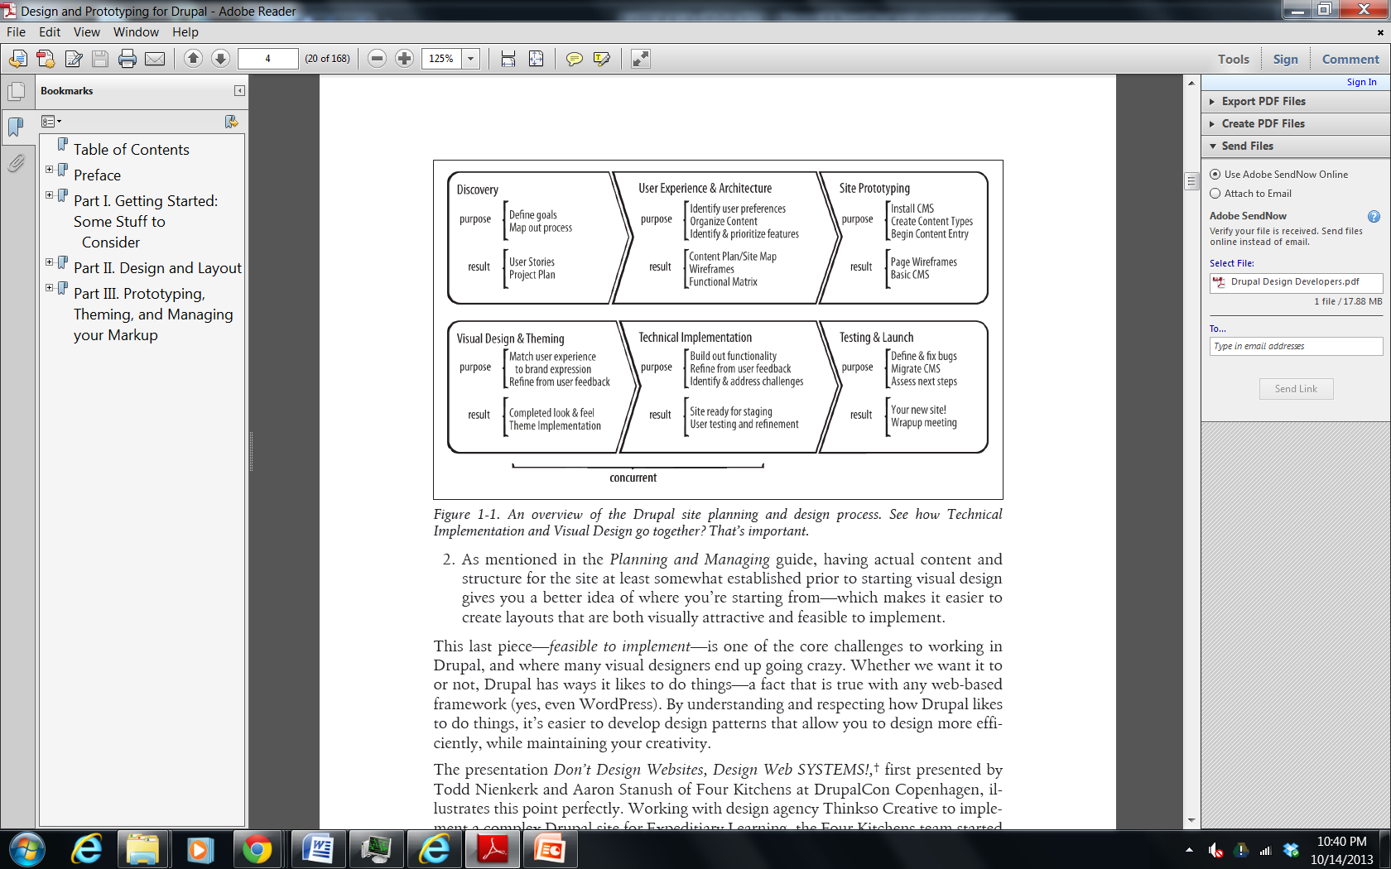

## Stakeholders and Resources

Below is a table the stakeholders and project resources and their high level functions of the RAPTOR Project.

Table 3 Stakeholders & Project Resources

| **Stakeholders & Project Resources** | **Function** |
| --- | --- |
| VA Medical Experts | Provide expert clinical knowledge, requirements, acceptance to project. Provide timely inspection and feedback to development team. |
| VA Data Center | Provide expert IT knowledge to project |
| VA PM/ Innovations Coordinator | Provide support to project regarding VA requirements |
| VA COTR | Provide contracting support to project |
| VA Sandbox Support | Provide sandbox support to project regarding VA. Respond to helpdesk tickets in a timely manner. |
| Project Manager | Project Management of schedule, milestones, risks and resources |
| System Architect | All aspects of implementation design |
| Programmer(s) | Design and development of RAPTOR application |
| Analyst | Development of the functional requirements and key measures |
| QA/QC | Development of the QA process and QC test scripts for testing |
| UI Specialist | Work on all aspects of user interface graphics and layouts |
| Computer Hardware Specialist | Configure and construct hardware deliverables; installs software |

# Methodology and Tools

This project will be predominantly managed using the “Agile” software development methodology “scrum” where appropriate. Scrum will ensure that user requirements, as they are defined and evolve, are properly incorporated and satisfied in RAPTOR. Scheduling will be primarily accomplished using MS Project. The Project Manager has the overall authority and responsibility for managing and executing this project according to this Project Plan.

## Bimonthly Progress Reports

The Bimonthly Progress Reports shall cover all work completed during the reporting period and work planned for the subsequent reporting period.  The report shall also identify any problems that arose and a description of how the problems were resolved.  If problems have not been completely resolved, the report shall provide an explanation.

The report shall monitor performance against the PMP and report any deviations. The SAN PM will keep in communication with the VA accordingly so that issues that arise are transparent to both parties to prevent escalation of outstanding issues.

The PM shall provide the Contracting Officer’s Technical Representative (COTR) with Bimonthly Progress Reports in electronic form in Microsoft Word.  The PM will ensure that the report’s data is accurate and consistent.

## Project Change Control Process

All changes to the WBS will require approval by the VA Innovation Coordinator and if the proposed change impacts any of the milestones, will require the approval of the VA COTR. The PM will formally write up the proposed change, documenting the reason for the change, all resource requirements and impacts, and any risks associated with it.

Additionally, SAN will utilize the Innovations Help Desk to configure and maintain the sandbox configuration. An example of this from Phase 1 is shown in the figure below.

Figure 5 Snapshot of Sandbox Tickets entered by development team

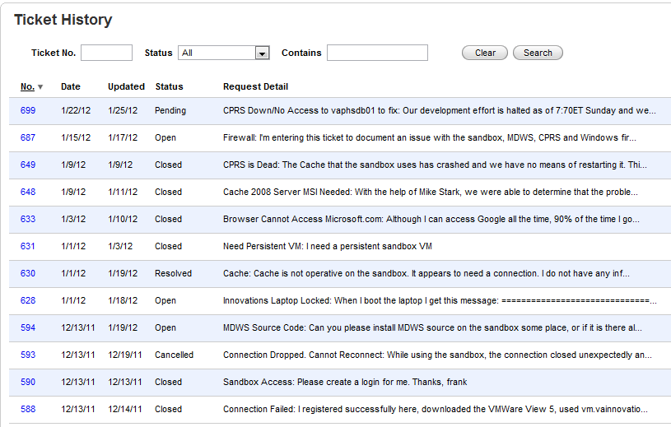

## Quality Management Approach

This project targets delivery of a platform comprising several software components that must be subjected to rigorous testing for milestone completion.

Each hardware and software component of the platform being developed will be subject to formalized testing before acceptance. Defects and bugs identified during testing will be tracked, where progress to resolution can be measured and reported in a collaborative manner.

* SME involvement in sprint planning
* Appropriate level of technical planning and architectural oversight
* Development progress visible in shared sandbox
* Periodic sprint touch points to ensure project is on track
* Developer unit tests created for critical components of the software
* Burn in testing of the hardware prior to delivery to data center

The Innovation configuration management will be maintained with support of the Innovations Help Desk.

## Risk Management Approach

SAN’s approach to manage risks for this project includes a methodical communications process by which the project team will identify, and categorize the various risks. The Options Analysis paper will document mitigation strategies.

A risk mitigation log will be maintained and updated throughout the project. The project team members have identified and documented all of the assumptions made during the project planning process, and then on a one by one basis, identify the risks that exist as a result of each assumption to the project based on the potential inaccuracies or inconsistencies that the assumption may exhibit.

A current log of risks and mitigations, as presently understood is provided in Appendix B. Risks are categorized by:

* Type: Logistical – risk from resource availability, Technical – development issues
* Schedule Impact – low, medium, high impact on schedule

## Performance Measures

SAN shall monitor performance against the established schedule, milestones, risks and resource support outlined in the approved PMP.  SAN shall report any deviations in the Bimonthly Progress Report. As a minimum, the following metrics shall be included:

Table 4 Performance Standard & Measures

| Required Deliverables | Performance Standard | Acceptable level | Surveillance Methods |
| --- | --- | --- | --- |
| Contractor Project Management Plan | Work completed in established timeframe; PMP shall include both narrative and graphic format to display schedule, milestones, risks and resource support. Government acceptance of PMP. The PMP is an active document, a “snapshot in time” and maintained throughout the project. | 95% | 100% Inspection |
| Kick-off Agenda  And Technical Kickoff Meeting Minutes | The project kick-off meeting details the intended approach, work plan, and project schedule for each effort. The Contractor shall provide possible dates for VA approval. | 95% | 100% Inspection |
| Bimonthly Progress Reports | Bimonthly Progress Reports will provide detailed information about the work completed during the reporting period. Government acceptance of bi-Bimonthly reports. | 95% | 100% Inspection |
| Fully documented Software Coding for each Increment | Each increment is available for government inspection and testing. The code will be fully documented so that the code’s functional intent can be understood. | 95% | 100% Inspection |
| Product Build Upon Completion | Each software increment’s files will be uploaded into the government controlled environment (both sandbox and production). An additional copy can be provided at a government detailed designation (such as the Innovations Dropbox). | 95% | 100% Inspection |
| Software Code Generation Documentation | SAN will deliver user test case development, requirements verification, management, package technical design, development, test, product delivery and documentation. The documentation will be posted onto the VA Innovations wiki website. | 95% | 100% Inspection |
| UAT Test Cases  and UAT Test Procedures | Test Cases will be developed in a step-by-step procedure to allow them to be understood by non-technical personnel. Each test case will be representative of realistic (radiologist/ordering provider) user scenarios which will validate each enhancement under test. | 95% | 100% Inspection |
| Pilot Location Interfaces | SAN will develop working interfaces between the Production RAPTOR Prototype and each of the five VA Pilot locations (Puget Sound, Palo Alto, Fresno, Tucson, and the Sacramento Data Center) prior to the start of the actual UAT testing. | 95% | 100% Inspection |
| RAPTOR Equipment (RAPTOR Sandbox and Production)  and Warranties and Licenses for RAPTOR Equipment | SAN will provide hardware, software, warranty and licensing agreements to include all applicable system and client upgrades and updates as well as technical and hardware support. Government acceptance of deliverables. | 95% | 100% Inspection |
| User Acceptance Test Plan (UTAP) | The UATP will outline the UAT strategy to include the key focus areas, entry and exit criteria. The UATP shall including: Test Approach; Assumptions and Constraints; Setup of Test Environment to include validation of interfaces; Approach taken to develop Test Cases; Test Cases/Procedures; Test Period; Test Resource required at each pilot location; and, Process to Document Test Results. | 95% | 100% Inspection |
| UAT Test Report | SAN will gather all testing results to include any issues found, such as bugs, crashes, or missing functionality from each pilot location and document these findings in the UAT Test Report. | 95% | 100% Inspection |
| Close-Out Meeting Minutes  Project Summary and Production Integration/Transition Report  OSEHRA Checklist and Project Abstract (plus source code and developer documentation if not previously submitted)  Submission of Final Deliverables to OSEHRA- OSEHRA project web-link (submission webpage for record) | SAN will provide a re-cap of the project, list out all executed deliverables, and provide a summary of the progress in relation to the original project plan. SAN will provide lessons learned for the 5 pilot locations for transition of the prototype solution into the VA production environment. SAN will provide a Project Summary and Production Integration/Transition Report detailing the topics described above. | 95% | 100% Inspection |

1. Risk Log

|  |
| --- |
| **Risk #1: Innovation Sandbox** |
| **Type: Project functionality Impact: Schedule** |
| **Issue: The existing sandbox (cloud1) is non-optimal.** |
| **Mitigation: UI Development outside of the sandbox. Continue monitoring Innovations support for UAT. Request all access. Now migrating from cloud1 to cloud2 environment.** |
| **Impact: High impact to UAT and development** |

|  |
| --- |
| **Risk #2: Timely feedback** |
| **Type: Project functionality Impact: Schedule** |
| **Issue: Gaining timely functional feedback on project deliverables may be a challenge due to clinical priorities. Gaining timely technical feedback is critical for architecture.** |
| **Mitigation: Assist and support Innovator and UAT sites with flexible after hours meetings, timely deliverables. The project team will collaborate with additional stakeholders. This will resulted in additional requirements and a flexible configuration strategy. Lack of administrative support has resulted in outstanding action items not being addressed by users.** |
| **Impact: Medium to development and UAT** |

|  |
| --- |
| **Risk #3: MS OS and database** |
| **Type: Project technology Impact: Schedule** |
| **Issue: The PWS specifies Microsoft OS and database (MS SQL Server 2008). The development team initially recommended change to PWS to use an updated OS such as the open source LAMP stack instead.** |
| **Mitigation: Discussions with Region production coordinator on technology choices has resulted in redesign. We are moving forward with a MS SQL Server 2008 database. The risk is that the virtual and physical configurations may be out of synch.** |
| **Impact: Medium to architecture regarding technical platform** |

|  |
| --- |
| **Risk #4: DICOM Images & Viewer Integration** |
| **Type: Project technology Impact: Schedule** |
| **Issue: No obvious choice between commercial and open source DICOM image viewer is currently available.** |
| **Mitigation: We evaluated multiple options during design phase to determine most beneficial route to an integrated solution. We are moving forward with an embedded HTML5 viewer. We are designing to include VIX and CVIX web services for image integration.** |
| **Impact: Low to architecture regarding technical platform** |

|  |
| --- |
| **Risk #5: Data Storage** |
| **Type: Architecture Impact: Performance and Schedule** |
| **Issue: PWS has requirements that may benefit from storing updates back into VistA accessible data storage.** |
| **Mitigation: Engineer local storage solution alternative if write back to VistA accessible storage is not practical within project time frame. We have requested a meeting on additional enhancements that include data storage write back.** |
| **Impact: High to architecture and UAT** |

|  |
| --- |
| **Risk #6: Radiation Dose Reporting** |
| **Type: Project technology Impact: Performance and Schedule** |
| **Issue: Capturing radiation dosage directly from modality is preferred but may be impacted by lack of connectivity or API.** |
| **Mitigation: Provide alternate data entry mechanisms for radiation dosage. This was documented in the enhancements listing. We have requested a meeting on additional enhancements that includes dose monitoring enhancements.** |
| **Impact: High to architecture and UAT** |

|  |
| --- |
| **Risk #7: Contraindication Maintenance** |
| **Type: Application Maintenance Impact: Performance and Schedule** |
| **Issue: Contraindication factors evolve as knowledge, tools, and medications change; contraindication rules may become out of date if not maintained.** |
| **Mitigation: Train site administrators on contraindication maintenance** |
| **Impact: Low** |

|  |
| --- |
| **Risk #8: Innovation Project Management** |
| **Type: All aspects of project Impact: Performance and Schedule** |
| **Issue: Throughout the project, there has been a lack of communications and leadership by VA Innovations Project Management in providing guidance, approving invoices, provide timely feedback and support, and responding to the project risks. This has jeopardized the project.** |
| **Mitigation: Involve contracting and senior management** |
| **Impact: High** |

|  |
| --- |
| **Risk #9: Production Configuration of VA Software** |
| **Type: Architecture Impact: Performance and Schedule** |
| **Issue: Lack of production support and knowledge of MDWS, and CVIX. Closest MDWS and CVIX installations are reportedly thousands of miles away from Sacramento CA. We have been coordinating with VA on obtaining recent patches and installers to avoid duplication of effort and keep good configuration management.** |
| **Mitigation: Involve production support, contracting and senior management.** |
| **Impact: High to schedule** |

|  |
| --- |
| **Risk #10: Loss of Palo Alto as a UAT site** |
| **Type: Schedule Impact** |
| **Issue: Palo Alto, CA (the largest UAT site), has dropped out of the project. Losing the largest site puts pressure on the entire project management staff to find an alternative. The previous 4 months of meetings, action items, etc. has to be repeated to “get-up-to speed” alternative site(s). The loss of the largest site has jeopardized the project. The request for additional resources to “get-up-to speed” alternative site(s) was turned down and contracts sent a “no cost”mod.** |
| **Mitigation: By turning down the request for additional funding, the VA has assumed all responsibility to get new site “up to speed”.** |
| **Impact: Med** |

|  |
| --- |
| **Risk #11: Request of VistA Imaging MAG*3.0*138 (VistA Imaging eXchange)** |
| **Type: Schedule Impact** |
| **Issue: There are two options for the VA VIX code:**  **1) VA provides Patch 138 VIX and CVIX source code and installers. Patch 138 has been field tested but the VA has pushed back on providing this unreleased code.**  **2) VA provides Patch 119 VIX and CVIX source code and installers. Patch 119 is released and the source code should already be on the FOIA site (it is not there as of 3/7/14). The installers are not typically part of the FOIA release but since this is a VA project they should be able to provide us with the installers which would be very beneficial.**  **We would like to use the VIX/CVIX installers to prepare the environment for the Raptor VIX so it is very important that we get the installers.** |
| **Mitigation: The points of contact we suggest talking to are:**  **Linville, Kathleen (Kathleen.Linville@va.gov)**  **Devlin, Vitalia M. (vitalia.devlin@va.gov)**  **Carlson, Larry E. (Larry.Carlson2@va.gov)** |
| **Impact: Med** |